**DIR COMMAND**

**Show all directories**

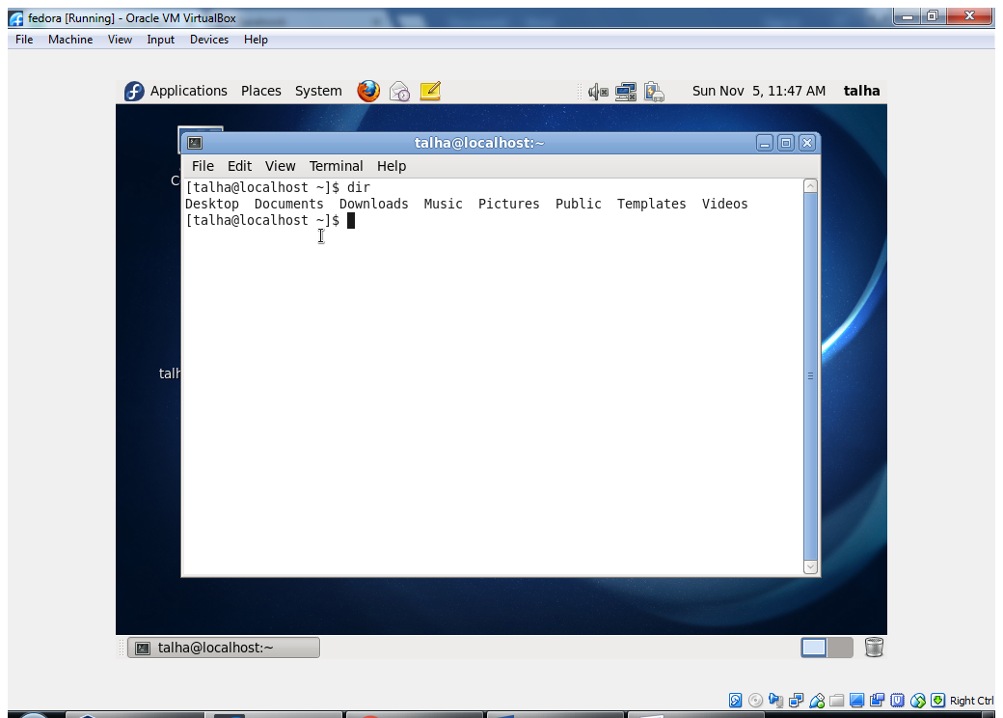

**DATE COMMAND**

**Show the system Date**

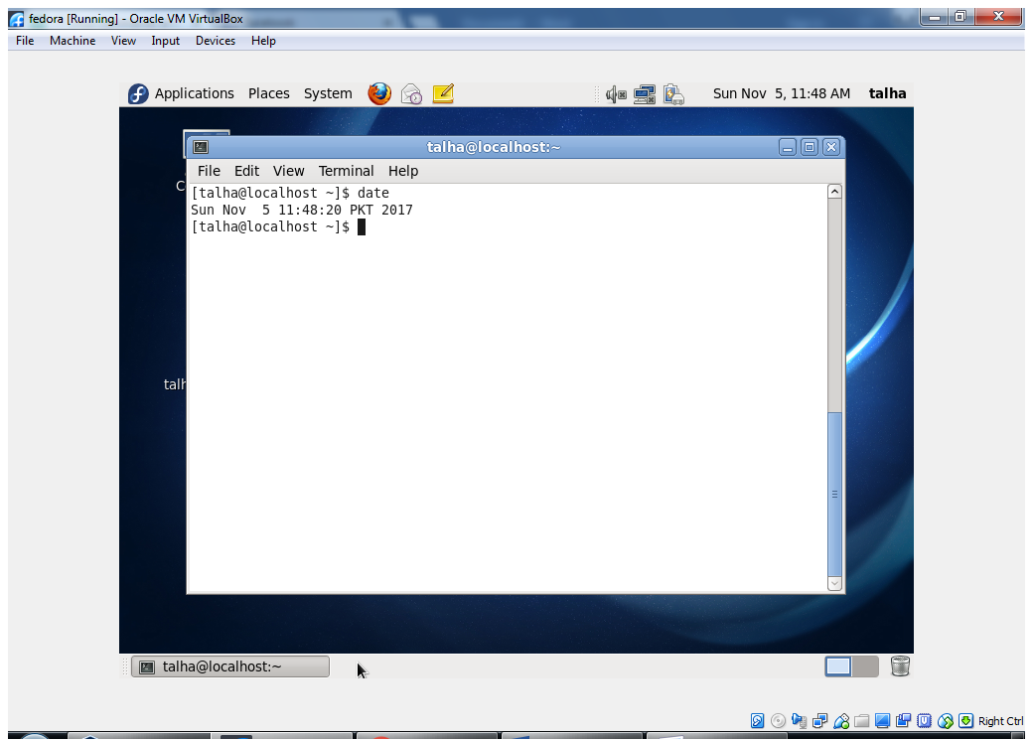

**Bzip2 Plugini**

**Compressed The Selected File**

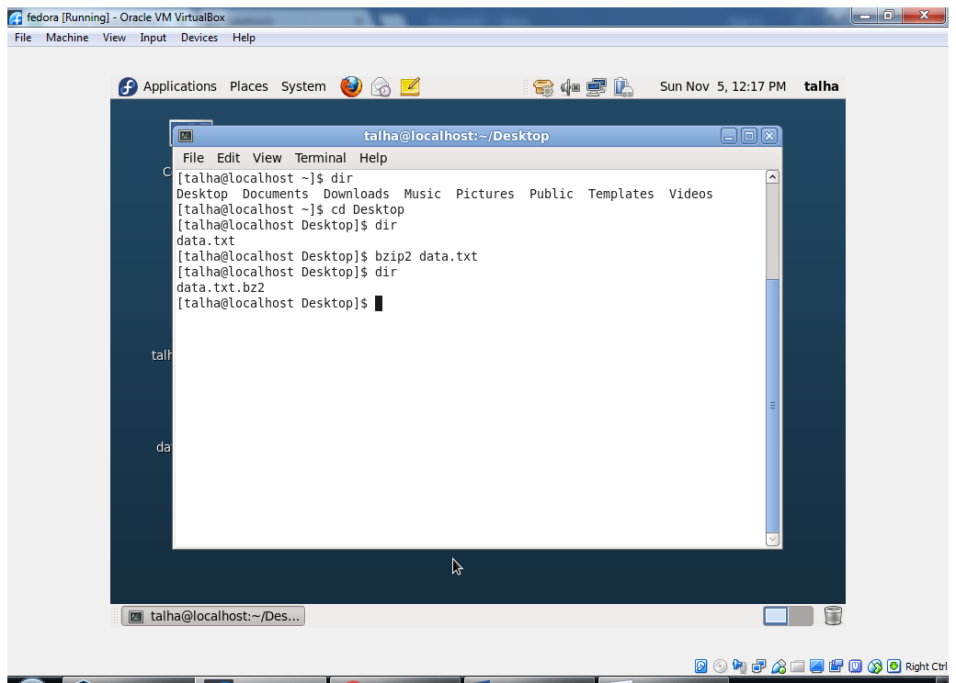

**CD COMMAND**

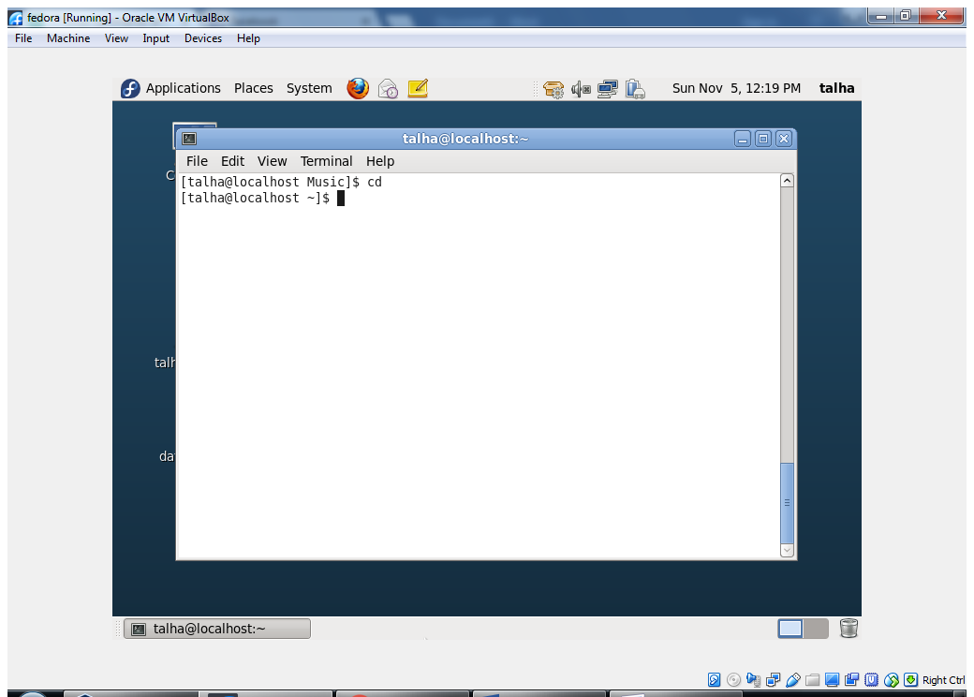

**Chmod command**

**Set The Permissons**

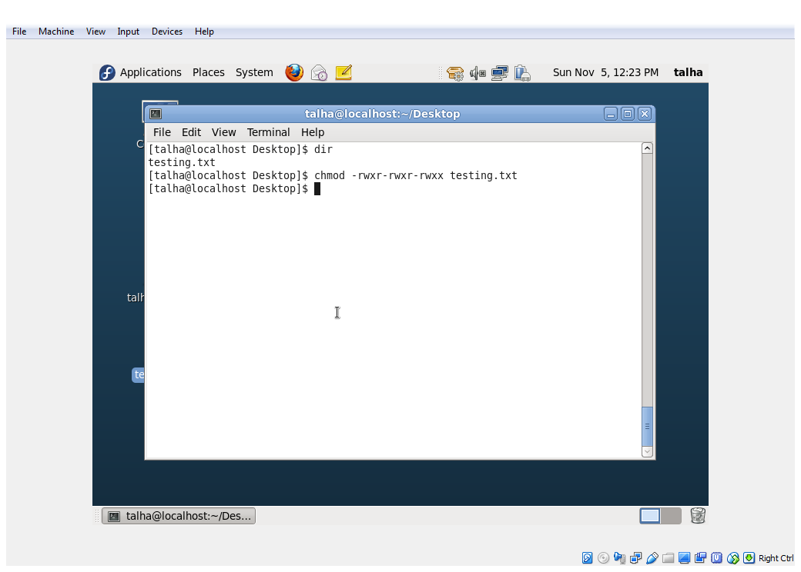

**DF COMMAND**

**Show the free space**

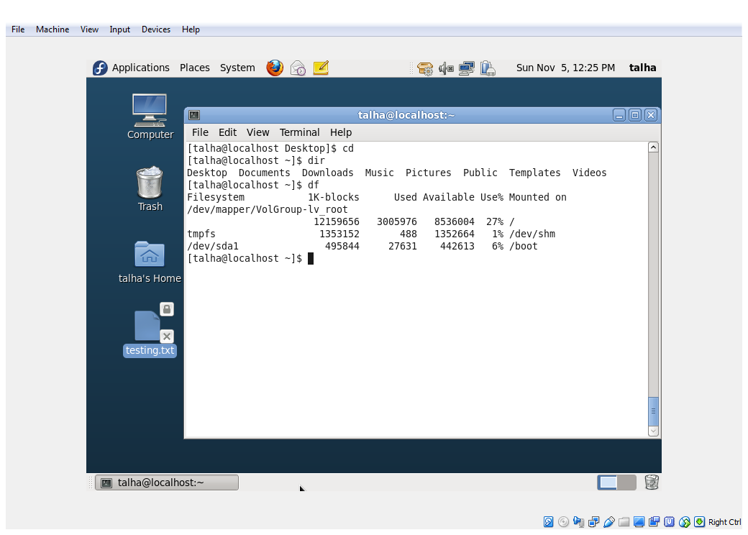

**Locate Command**

**Find FILE or PATH(/foldername/)**

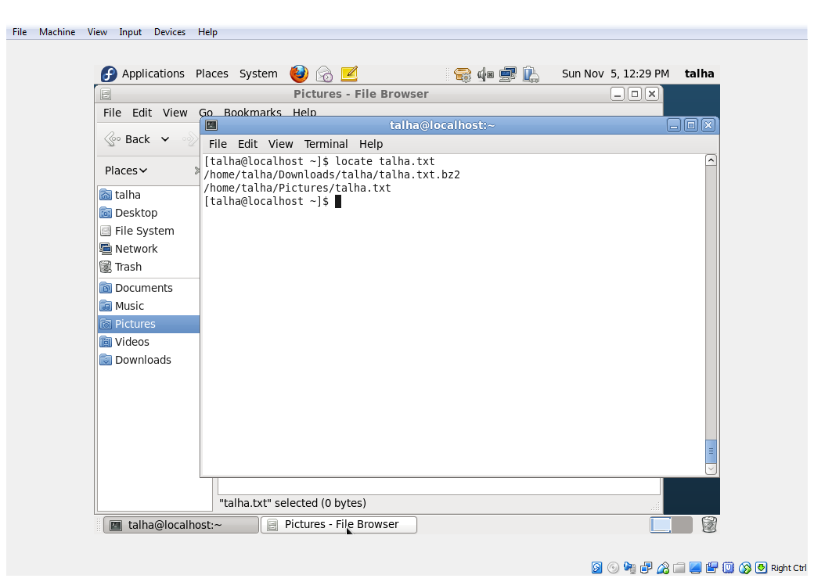

**WHOAMI COMMAND**

**Show The User Name**

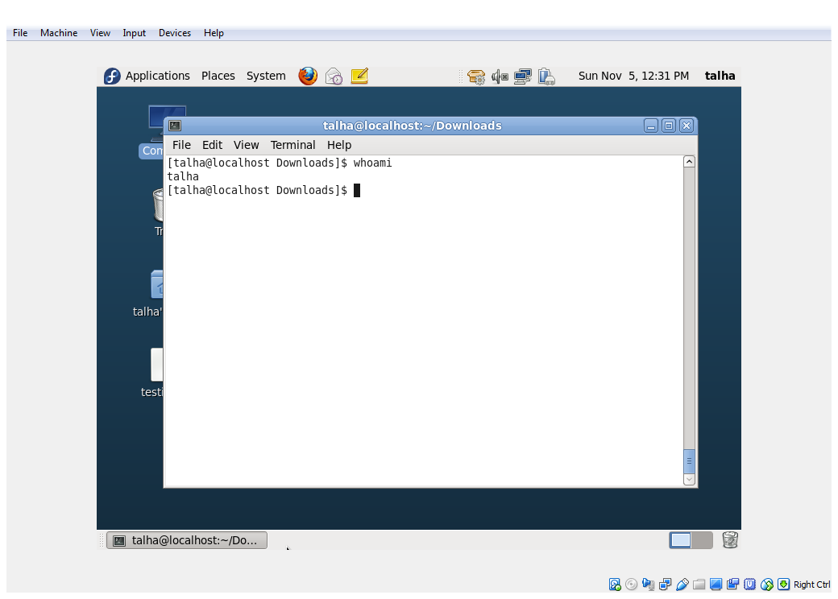

**LS OR DIR COMMAND**

**Show The Files of Directory**

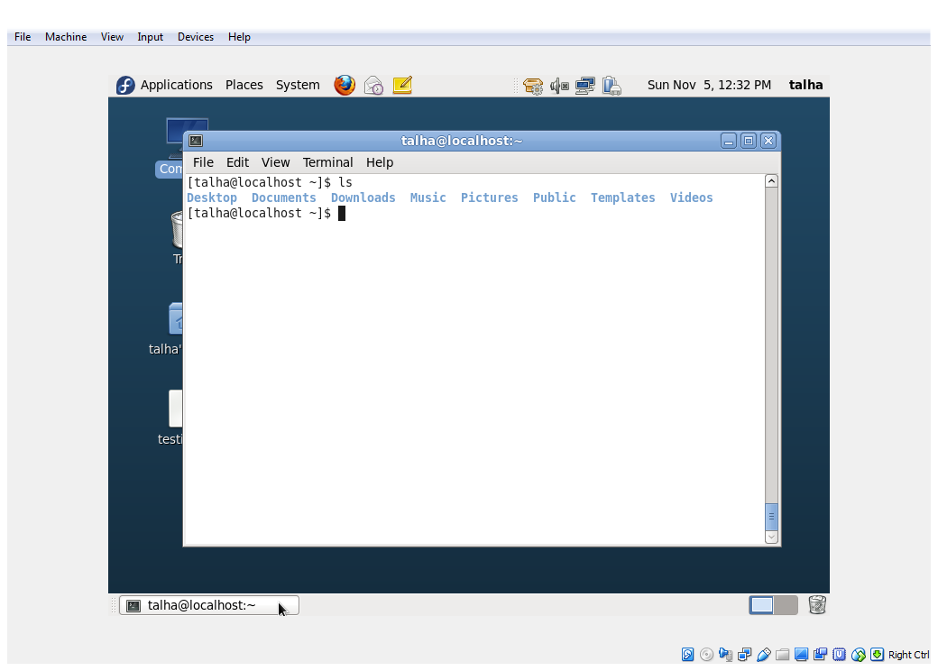

**MAN COMMAND**

**Format and display the user manual built into linux distributions**

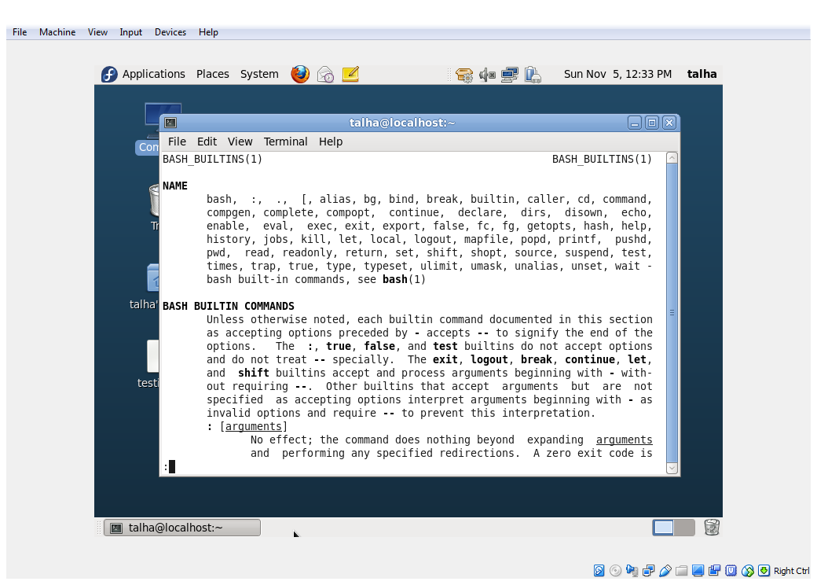

**MKDIR COMMAND**

**MAKE DIRECTORY OR FOLDER**

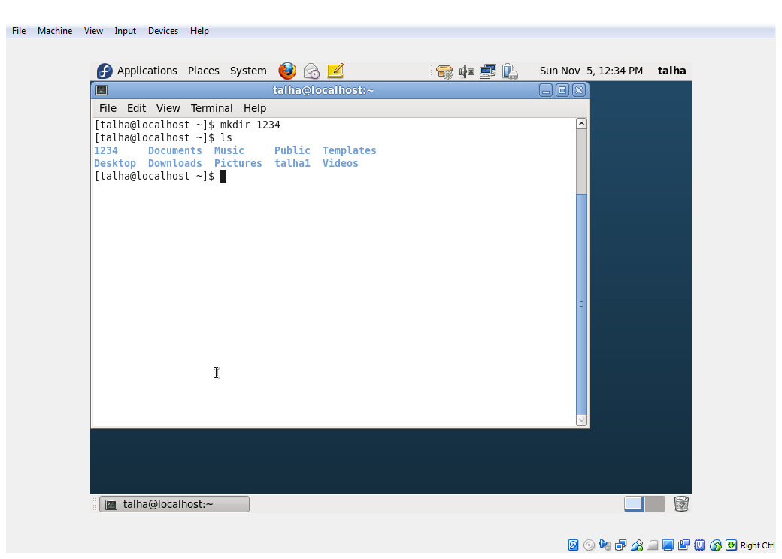

**RMDIR COMMAND**

**REMOVE DIRECTORY OR FOLDER**

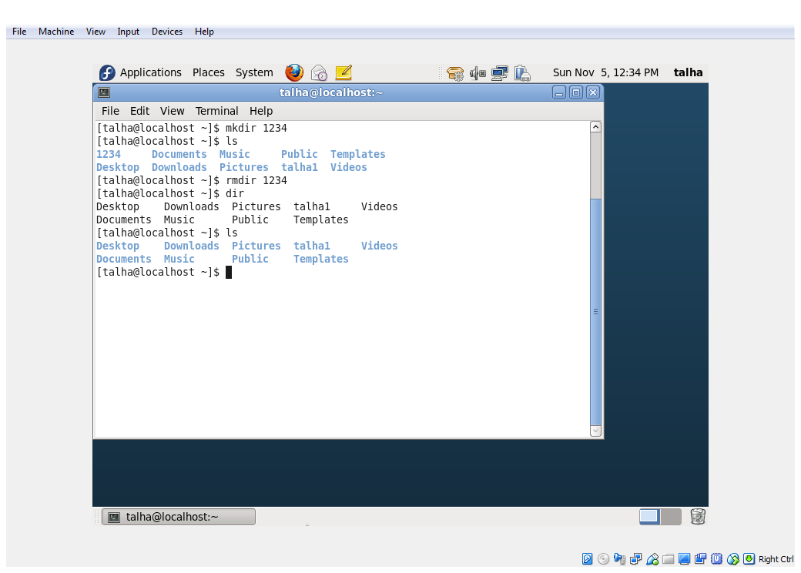

**CLEAR COMMAND**

**CLEAR ALL TEXT**

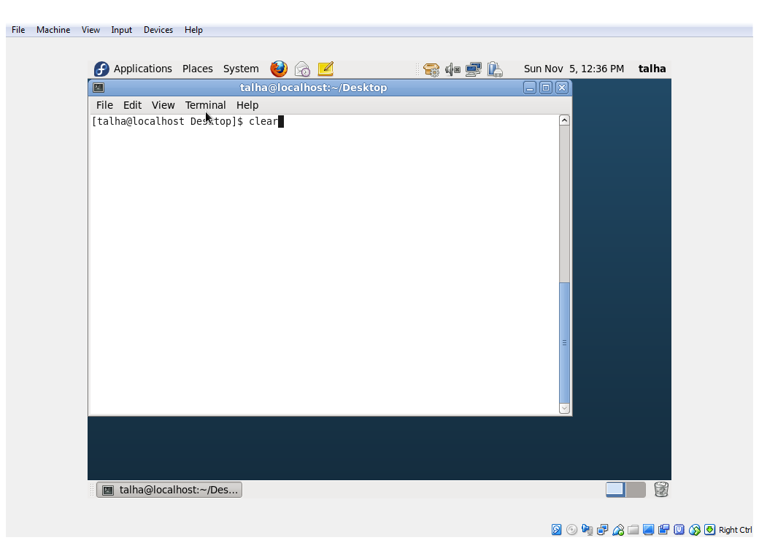

**EXIT COMMAND**

**close the Terminal**

